PROJECT REPORT
TITLE OF THE PROJECT:
Superstore Sales Analysis & Forecasting using Python and Power BI.
INTRODUCTION:
This project focuses on analyzing Superstore sales data to understand business performance across different categories, regions, and customer segments. The objective is to identify key business insights and improve decision-making using data analysis and visualization tools.
Python is used for data preprocessing and exploratory data analysis, while Power BI is used to create an interactive dashboard for visualization and forecasting.
OBJECTIVE:
- To analyze sales, profit, and discount patterns
- To identify top-performing categories and regions
- To understand the impact of discount on profit
- To visualize monthly sales trends
- To build an interactive dashboard using Power BI
- To apply basic machine learning model for prediction
TOOLS USED:
- Python (Pandas, Matplotlib, Scikit-learn)
- Power BI Desktop
- Excel / CSV Dataset
DATASET DESCRIPTION:
The dataset contains Superstore transaction data including:
- Order Date
- Ship Date
- Category
- Region
- Sales
- Profit
- Quantity
- Discount
- Ship Mode
DATA PREPROCESSING (PYTHON):
The dataset was cleaned and transformed using Python:
- Converted Order Date and Ship Date into datetime format
- Created new feature: Delivery Days
- Extracted Order Month from Order Date
- Checked and handled missing values
- Performed grouping and aggregation for analysis
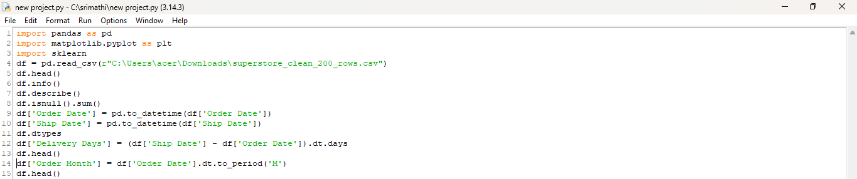
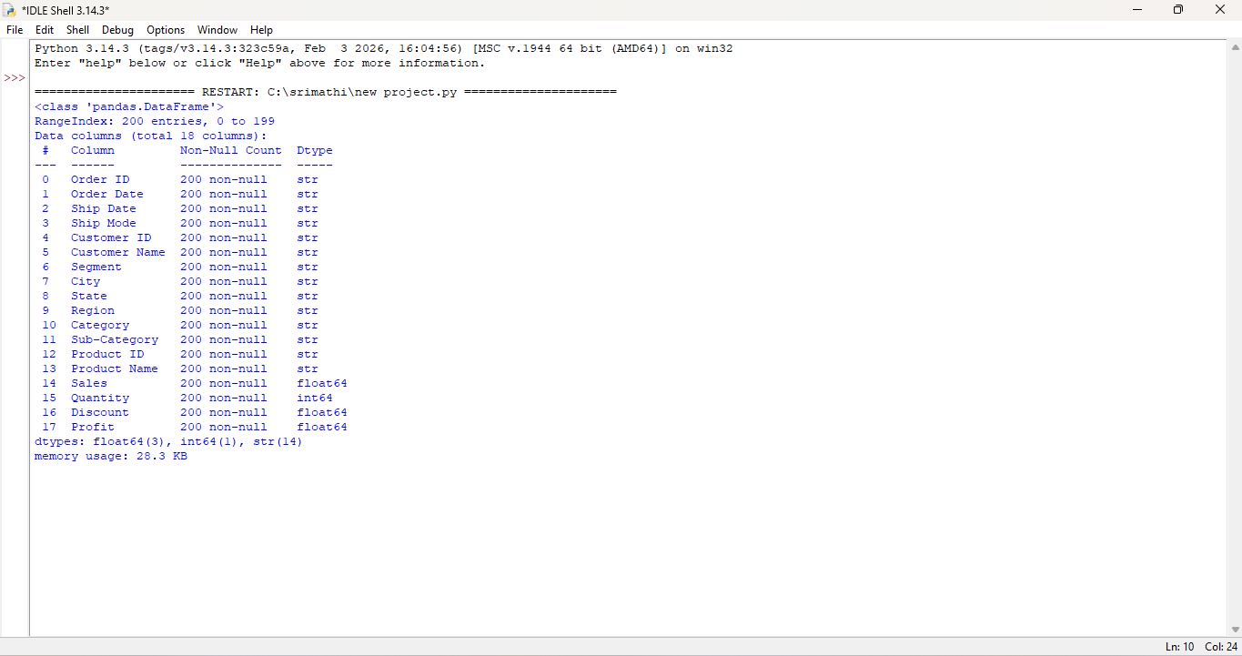

EXPLORATORY DATA ANALYSIS (EDA):
Key Analysis performed:
- Sales by Category
- Profit by Region
- Monthly Sales Trend
- Relationship between Discount and Profit
Observations:
- Technology category generated highest sales
- Western region showed highest profit
- Higher discount negatively impacted profit
- Sales showed seasonal monthly variation
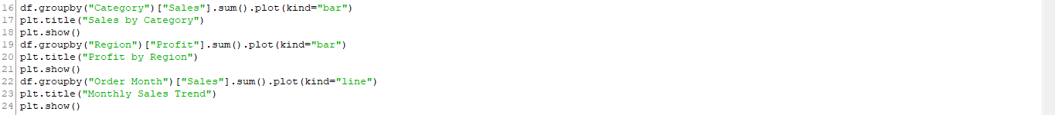
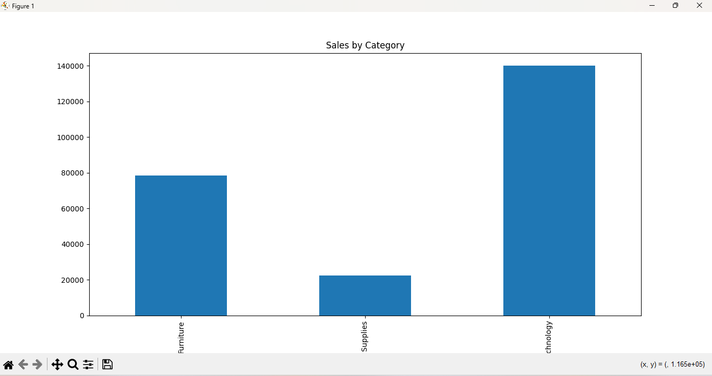
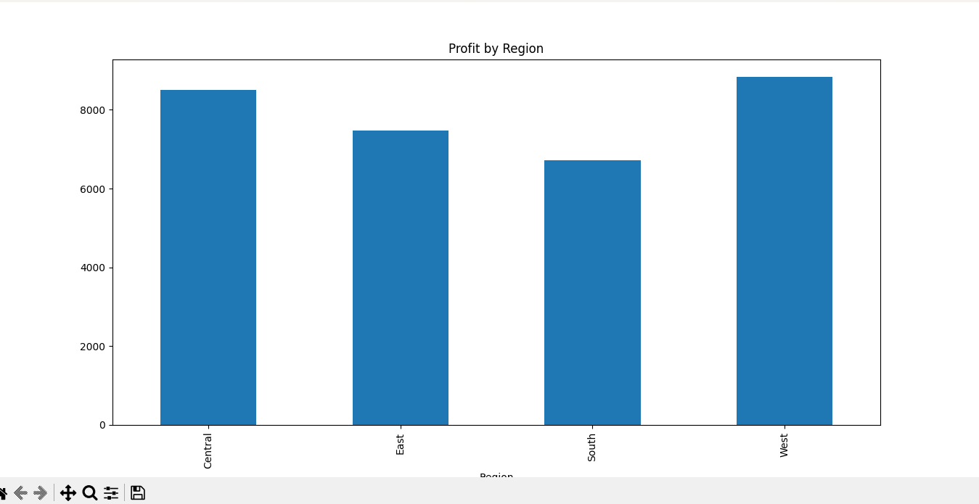
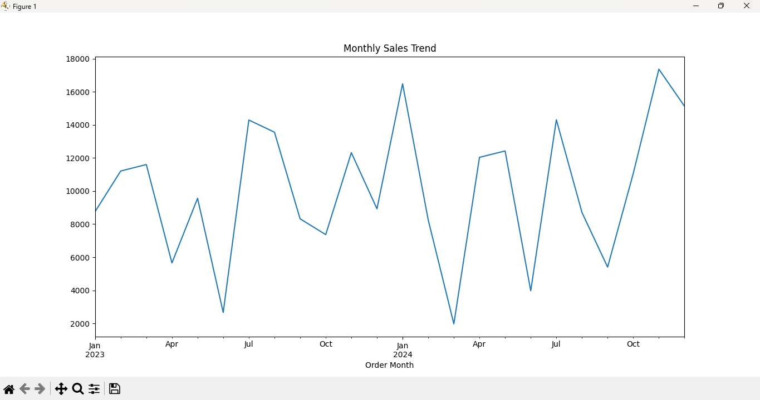

MACHINE LEARNING MODEL (PYTHON):
A Linear Regression model was applied to predict Profit based on:
- Sales
- Quantity
- Discount
Model Evaluation:
- R² Score was used to evaluate model performance
- The model showed moderate accuracy in predicting profit
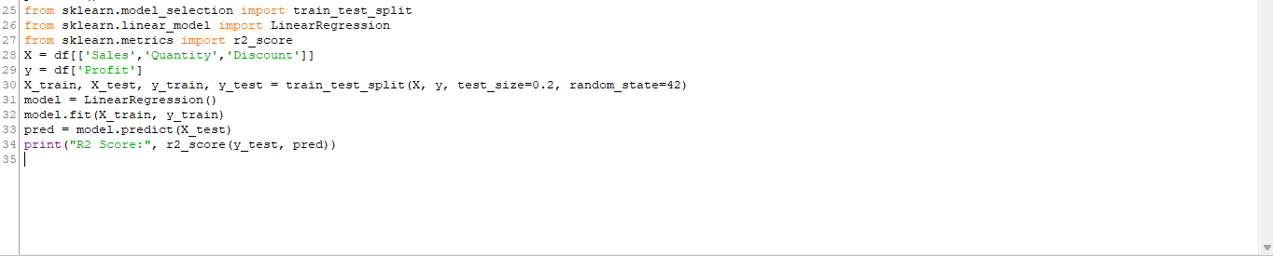
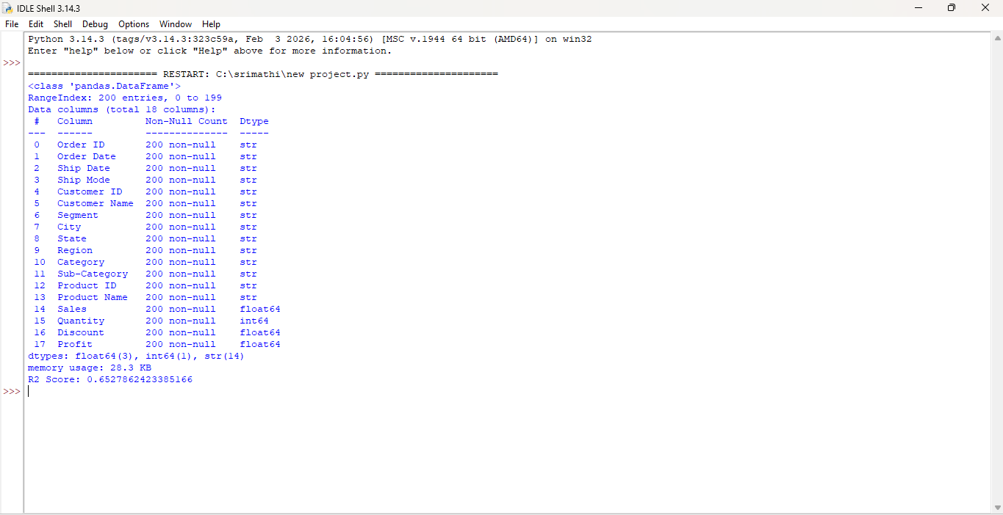

POWER BI DASHBOARD:
An interactive dashboard was created in Power BI including:
KPI Cards:
- Total Sales
- Total Profit
- Total Quantity
- Average Discount
- Average Delivery Days
Visualizations:
- Sales by Category (Bar Chart)
- Profit by Region (Column Chart)
- Monthly Sales Trend (Line Chart)
- Discount vs Profit (Scatter Plot)
- Top 10 Products by Sales (Table)
Filters (Slicers):
- Category
- Region
- Segment
- Order Date
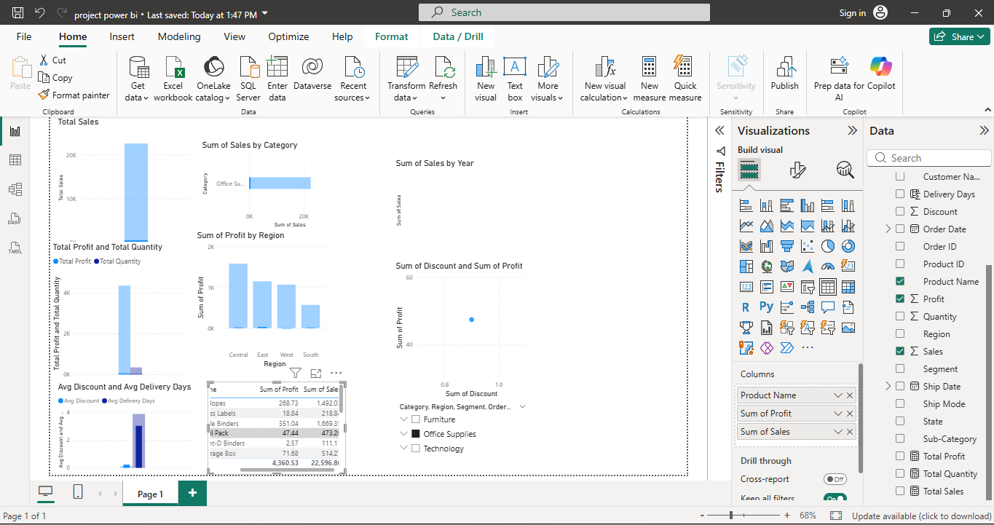

BUSINESS INSIGHTS:
- Technology category generates highest revenue
- Furniture has high sales but low profit margin
- High discount leads to reduced profit
- Central region underperforms in profit
- Sales show increasing monthly trend
- Delivery time impacts operational efficiency
CONCLUSION:
This project successfully demonstrates how data analysis and visualization can help businesses make informed decisions. Python was used for data processing and machine learning, while Power BI provided an interactive dashboard for business insights.
The project helps in understanding sales patterns, customer behavior, and profitability trends, which are essential for business growth and strategy planning.

